Experiment No. 1
Software Engineering Lab
Topic | Agile Requirements Gathering with User Stories (For Functional Requirements) - applied to the ContextGuard project
Aim | To identify the functional requirements of the ContextGuard project (a repository-context-aware verification layer for reliable LLM-based code review) by writing Agile user stories.
Team | Snehal Kumar - B054 | Suhanee Midha - B062 | Kian Jain - B131
Learning Outcome
- Write effective user stories for the functional requirements of a selected project.
- Define acceptance criteria and a Definition of Done for each story.
- Maintain different versions of the requirement document as the project evolves.

Part A — Theory

Agile Requirements Gathering with User Stories
Like traditional projects, Agile projects begin with requirements gathering — understanding the goals of the end users and stakeholders is the essential first step. Agile, however, does not try to freeze every detail up front. Instead, the goal is to capture just enough information to have a meaningful conversation with the customer later, in the form of short, customer-facing descriptions called user stories.
A user story is a placeholder for a future conversation about the required functionality, not a final specification. Delaying the detailed conversation until shortly before development reduces the waste seen in projects where detailed requirements are gathered early and become invalid before work even begins; if a feature is dropped by the customer, no time was wasted analyzing it in detail.
A widely used structure for brainstorming user stories is:
As a [Type of User], [Function to Perform] so that [Business Value]
This keeps stories focused on customer and business value rather than technical implementation. At the start of a project, key stakeholders are brought together to brainstorm possible stories at this level. Elaborating the user types first makes it easier to determine what functionality each type of user needs. It is normal for some stories to surface later — Agile absorbs new requests as they are discovered, which reduces pressure on the customer to “get it all right” up front.
The point of this stage is not to decide how a story will be implemented, only to understand the scope of the system. Stories are later prioritised with the customer, a subset is chosen for the next release, and an even smaller subset is chosen for the next iteration (a fixed period, typically 1–4 weeks). Detailed conversations that clarify ambiguity happen during iteration planning, and close contact with the customer continues through development.

Aspect | Traditional Requirements | Agile User Stories
Detail level | Fully detailed up front | Just enough detail to start a conversation
Timing | Gathered once, early | Elaborated continuously through iterations
Owner of detail | Business analyst / document | Ongoing conversation with the customer
Risk | Requirements may become invalid before build | Change is expected and absorbed each iteration

Format for Writing User Stories
A user story typically follows a simple template, followed by one or more acceptance criteria written as Given / When / Then conditions:
As a <type of user>, I want <to perform some task> so that I can <achieve some goal/benefit/value>
Example — As a customer, I want to withdraw cash from an ATM, so that I don't have to wait in line at the bank.
- Acceptance Criterion 1: Given the account is credit-worthy, the card is valid, and the dispenser contains cash, When the customer requests cash, Then the account is debited, cash is dispensed, and the card is returned.
- Acceptance Criterion 2: Given the account is overdrawn and the card is valid, When the customer requests cash, Then a rejection message is displayed and no cash is dispensed.
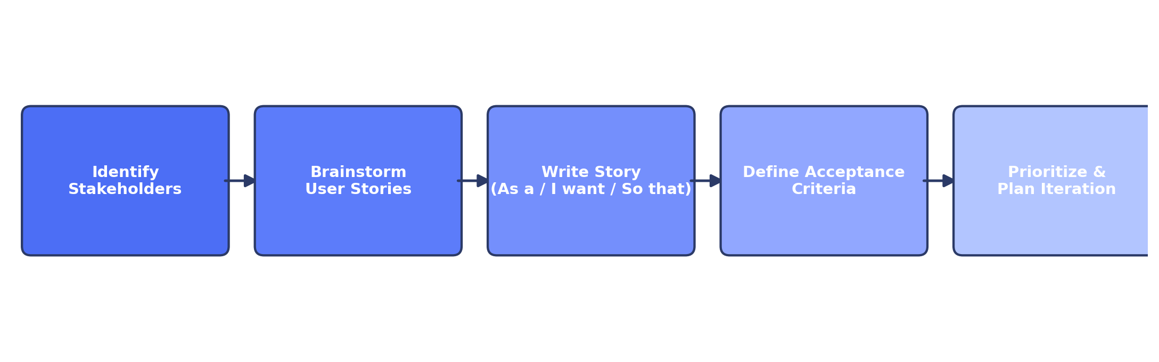
Fig. A1 — Agile flow from stakeholder identification to iteration planning

Part B — Documenting the User Stories of ContextGuard
Application: “ContextGuard” — a repository-context-aware verification layer for reliable LLM-based code review. The system takes in a GitHub pull request, retrieves relevant repository context using hybrid dense and sparse retrieval, synthesises the test oracle needed to check a flagged fix, and re-verifies the AI reviewer's own verdict before it reaches a developer, through role-based views for developers, reviewers, and engineering managers.
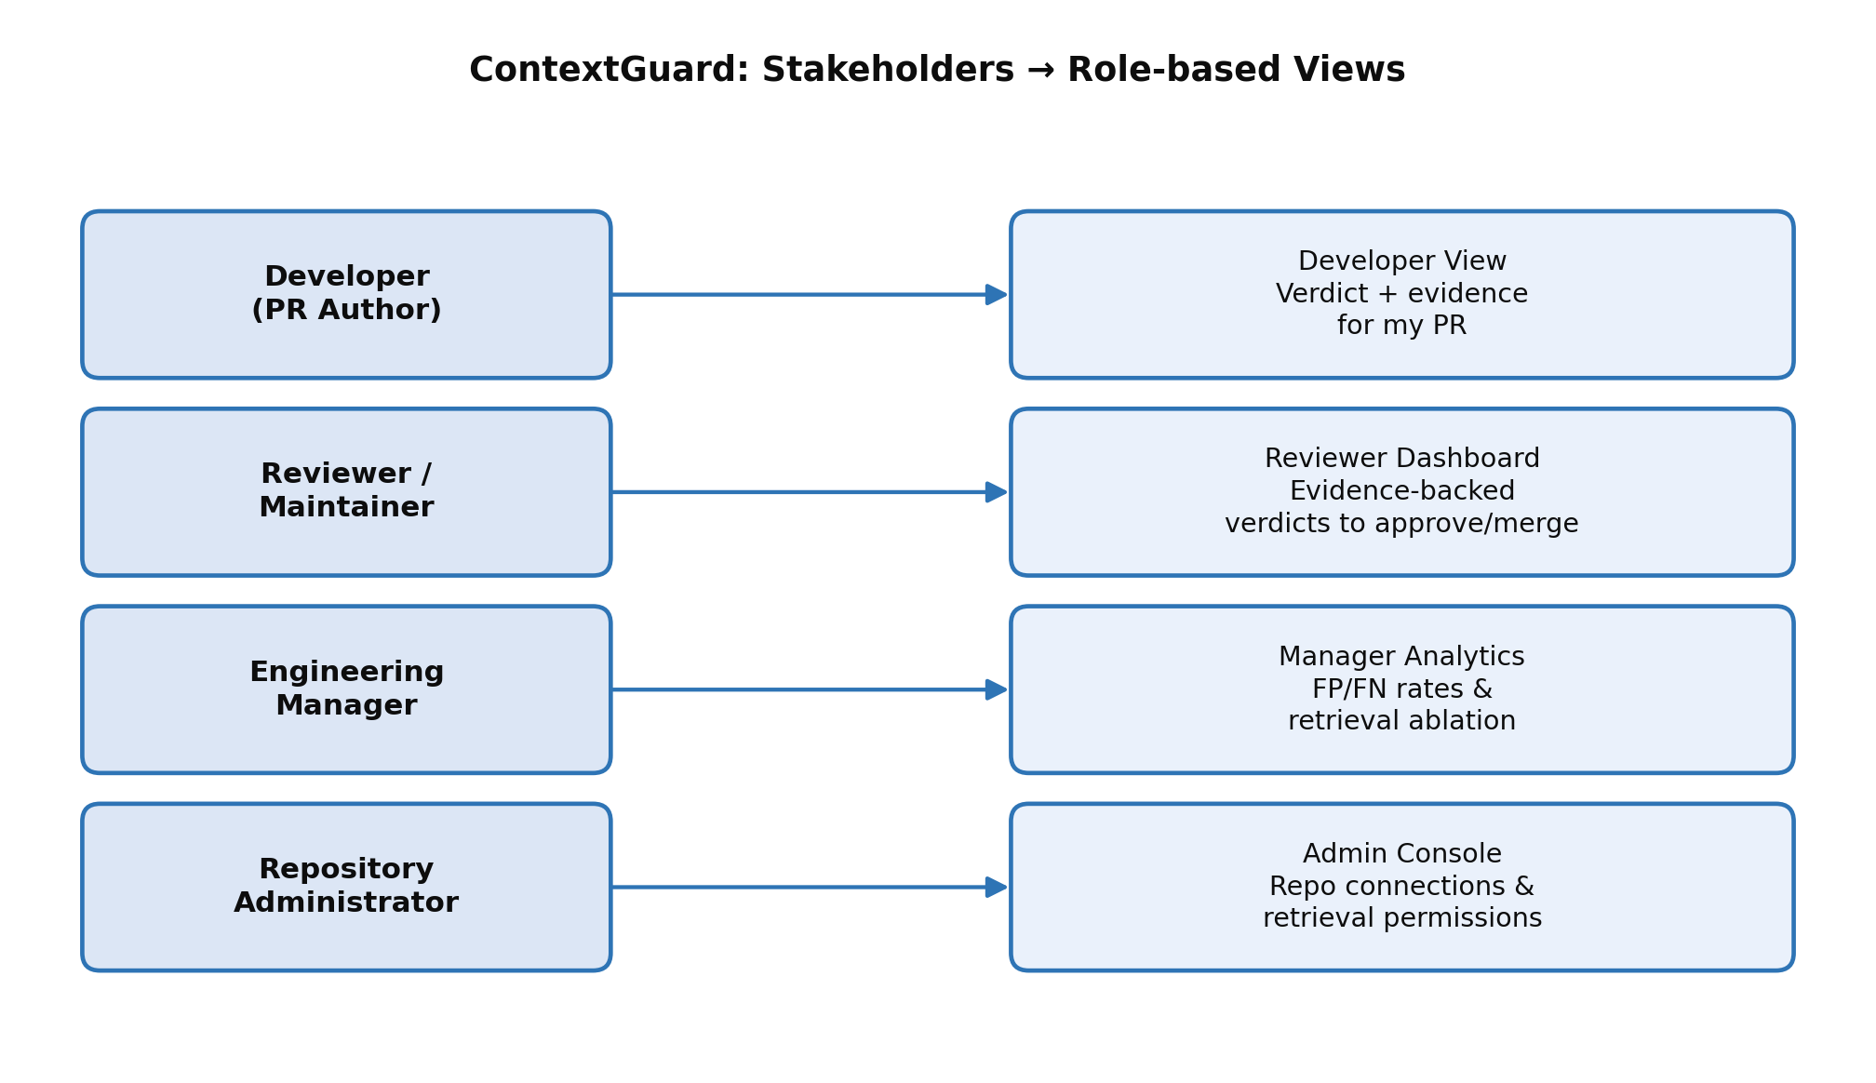
Fig. B1 — Stakeholder-to-dashboard mapping for ContextGuard

B.1 Stakeholders / Types of Users Identified
- Developer (PR Author) — submits pull requests and receives the verified review verdict.
- Reviewer / Maintainer — human reviewer who approves or merges pull requests based on the AI and verification evidence.
- Engineering Manager — monitors review-quality metrics and retrieval-ablation results across the team.
- Repository Administrator — connects repositories to ContextGuard and configures retrieval permissions.
- QA / Test Auditor — audits the automatically generated verification tests before they are trusted.
- Security / Compliance Reviewer — confirms that context retrieval stays within the approved, non-restricted scope.

B.2 User Stories by Role
Developer (PR Author)
- As a developer, I want to submit my pull request for automated review so that I get fast, consistent feedback without waiting for a human reviewer to be free.
- As a developer, I want to see whether a non-compliant flag on my PR was confirmed or corrected by verification evidence so that I don't waste time fixing something that was never actually broken.
- As a developer, I want to view the generated test cases that justified a flag so that I understand exactly what behaviour was expected of my code.
- As a developer, I want to be notified as soon as the verified verdict is ready so that I can act on the feedback immediately.
Reviewer / Maintainer
- As a reviewer, I want to see an evidence-backed verdict instead of a bare AI opinion so that I can approve or reject a PR with confidence.
- As a maintainer, I want a PR flagged as non-compliant to be automatically re-verified against synthesised tests before I see it so that I am not misled by the AI reviewer's own over-caution.
- As a reviewer, I want ContextGuard to retrieve similar functions and existing tests from the repository so that generated tests reflect the project's actual conventions.
- As a reviewer, I want to override a ContextGuard verdict manually when I disagree so that I retain final authority over what gets merged.
Engineering Manager
- As a engineering manager, I want to see the false-positive and false-negative rates of the AI reviewer with and without ContextGuard so that I can measure whether the tool is actually improving review quality.
- As a engineering manager, I want an ablation view comparing dense-only, dense-with-sparse, and full-pipeline retrieval so that I can justify the cost of the added retrieval layer.
- As a engineering manager, I want to see which repositories are connected and their verification coverage so that I know where the tool is, and is not, yet active.
- As a engineering manager, I want to export the comparative evaluation report so that I can share verification-quality improvements with stakeholders outside the team.
Repository Administrator
- As a repository administrator, I want to connect a GitHub repository to ContextGuard with read access so that it can automatically retrieve diffs, issues, and metadata needed for verification.
QA / Test Auditor
- As a QA engineer, I want to review the synthesised verification tests before they are trusted so that I can catch a badly generated test rather than let it silently validate a wrong fix.
Security / Compliance Reviewer
- As a security reviewer, I want to confirm that repository-context retrieval never pulls restricted files outside the approved scope so that confidential code is never exposed to the retrieval or generation pipeline.

B.3 Acceptance Criteria for Key Stories
Acceptance criteria for the highest-priority (P0) stories were defined in Given / When / Then form so that each story has a clear Definition of Done:
Story | Acceptance Criterion (Given / When / Then)
PR flagged as non-compliant is verified before the final verdict | Given the AI reviewer flags a PR as non-compliant and proposes a fix, When ContextGuard retrieves repository context and synthesises verification tests, Then both the original code and the proposed fix are run against the synthesised tests, And if both behave identically the flag is corrected to compliant, And if the fix changes behaviour the flag is confirmed, And the developer sees the final verdict along with the evidence used.
Repository connection requires read-access authorisation | Given an administrator initiates connecting a repository to ContextGuard, When the OAuth read-access grant is completed, Then the repository status is set to 'connected', And ContextGuard cannot begin retrieval or verification for that repository until it is connected, And on successful connection a confirmation notification is sent to the administrator.
Dashboard reflects the verification outcome for a merged PR | Given a PR verdict has been finalised (confirmed or corrected), When the verdict is recorded, Then the dashboard's false-positive / false-negative counters are updated accordingly, And a verdict record is created with pr_id, repository_id, original_verdict and final_verdict, And the reviewer receives a confirmation notification of the updated verdict.
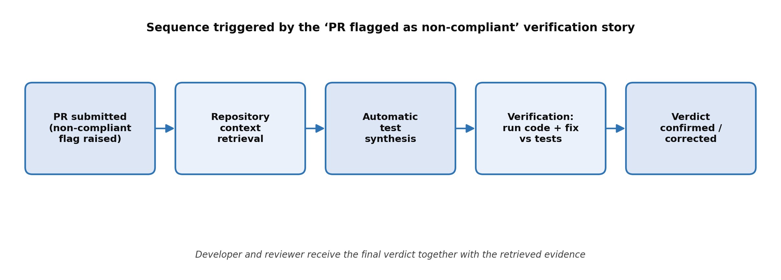
Fig. B2 — Sequence flow triggered by the ‘PR flagged as non-compliant’ verification story

B.4 Versioning the Requirement Document
This document represents Version 1.0 of the ContextGuard functional requirements, covering only the P0 (must-have) stories agreed for the prototype. As stories are prioritized and refined with stakeholders during iteration planning, this document will be updated (V1.1, V1.2 …) to record new stories discovered, story splits, and any acceptance-criteria changes, while superseded versions are retained for traceability.

Conclusion
Agile user stories provided a lightweight, customer-focused way to capture the functional requirements of ContextGuard without over-specifying the system up front. Structuring stories as “As a … I want … so that …”, paired with Given/When/Then acceptance criteria, made it possible to identify the core P0 flows — repository onboarding, fix-guided verification, and the evidence-backed verdict dashboard — that will drive the first iteration of development.

